What is SQL Joins?
An SQL JOIN clause combines rows from two or more tables. It creates a set of rows in a temporary table.

How to Join two tables in SQL?
A JOIN works on two or more tables if they have at least one common field and have a relationship between them.
JOIN keeps the base tables (structure and data) unchanged.

Join vs. Subquery
- JOINs are faster than a subquery and it is very rare that the opposite.
- In JOINs the RDBMS calculates an execution plan, that can predict, what data should be loaded and how much it will take to processed and as a result this process save some times, unlike the subquery there is no pre-process calculation and run all the queries and load all their data to do the processing.
- A JOIN is checked conditions first and then put it into table and displays; where as a subquery take separate temp table internally and checking condition.
- When joins are using, there should be connection between two or more than two tables and each table has a relation with other while subquery means query inside another query, has no need to relation, it works on columns and conditions.

SQL JOINS: EQUI JOIN and NON EQUI JOIN
The are two types of SQL JOINS - EQUI JOIN and NON EQUI JOIN
1) SQL EQUI JOIN :
The SQL EQUI JOIN is a simple SQL join uses the equal sign(=) as the comparison operator for the condition. It has two types - SQL Outer join and SQL Inner join.
2) SQL NON EQUI JOIN :
The SQL NON EQUI JOIN is a join uses comparison operator other than the equal sign like >, <, >=, <= with the condition.
SQL EQUI JOIN : INNER JOIN and OUTER JOIN
The SQL EQUI JOIN can be classified into two types - INNER JOIN and OUTER JOIN
1. SQL INNER JOIN
This type of EQUI JOIN returns all rows from tables where the key record of one table is equal to the key records of another table.
2. SQL OUTER JOIN
This type of EQUI JOIN returns all rows from one table and only those rows from the secondary table where the joined condition is satisfying i.e. the columns are equal in both tables.
In order to perform a JOIN query, the required information we need are:
a) The name of the tables
b) Name of the columns of two or more tables, based on which a condition will perform.
Syntax:
FROM table1
join_type table2
[ON (join_condition)]
Parameters:
Name | Description
table1, table2 | Tables participating in joining.
join_type | Type of the join.
join_condition | Some condition. This is optional.
Pictorial Presentation of SQL Joins:
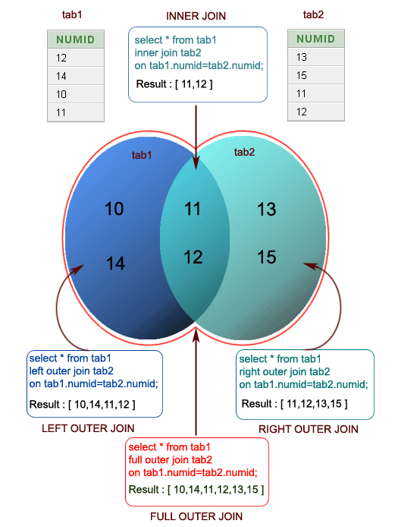
Example:
Sample table: company

Sample table: foods

To join two tables 'company' and 'foods', the following SQL statement can be used :
SQL Code:
SELECT company.company_id,company.company_name,
foods.item_id,foods.item_name
FROM company,foods;
Copy
Output:
COMPAN COMPANY_NAME ITEM_ID ITEM_NAME
------ ------------------------- -------- ---------------
18 Order All 1 Chex Mix
18 Order All 6 Cheez-It
18 Order All 2 BN Biscuit
18 Order All 3 Mighty Munch
18 Order All 4 Pot Rice
18 Order All 5 Jaffa Cakes
18 Order All 7 Salt n Shake
15 Jack Hill Ltd 1 Chex Mix
15 Jack Hill Ltd 6 Cheez-It
15 Jack Hill Ltd 2 BN Biscuit
15 Jack Hill Ltd 3 Mighty Munch
15 Jack Hill Ltd 4 Pot Rice
15 Jack Hill Ltd 5 Jaffa Cakes
15 Jack Hill Ltd 7 Salt n Shake
16 Akas Foods 1 Chex Mix
16 Akas Foods 6 Cheez-It
16 Akas Foods 2 BN Biscuit
16 Akas Foods 3 Mighty Munch
16 Akas Foods 4 Pot Rice
16 Akas Foods 5 Jaffa Cakes
16 Akas Foods 7 Salt n Shake
.........
.........
.........
JOINS: Relational Databases

What is Equi Join in SQL?
SQL EQUI JOIN performs a JOIN against equality or matching column(s) values of the associated tables. An equal sign (=) is used as comparison operator in the where clause to refer equality.
You may also perform EQUI JOIN by using JOIN keyword followed by ON keyword and then specifying names of the columns along with their associated tables to check equality.
Syntax:
SELECT column_list
FROM table1, table2....
WHERE table1.column_name =
table2.column_name;
or
SELECT *
FROM table1
JOIN table2
[ON (join_condition)]
Pictorial representation:
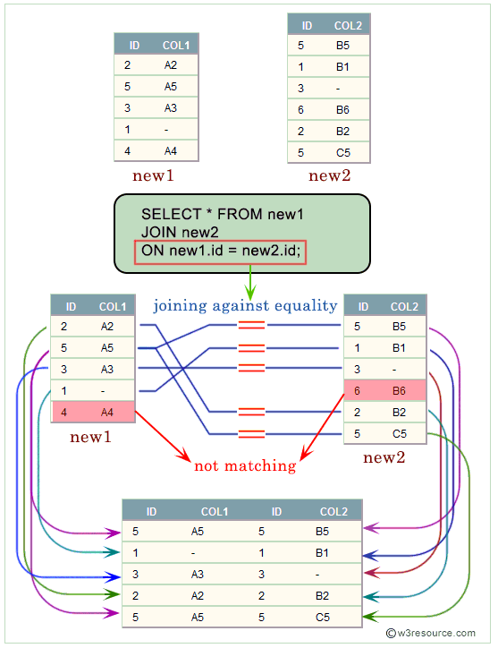
Example:
Here is an example of Equi Join in SQL.
Sample table: agents

Sample table: customer

To get agent name column from agents table and cust name and cust city columns from customer table after joining said two tables with the following condition -
1. working area of agents and customer city of customer table must be same,
the following SQL statement can be used:
SQL Code:
SELECT agents.agent_name,customer.cust_name,
customer.cust_city
FROM agents,customer
WHERE agents.working_area=customer.cust_city;
Copy
Output:
AGENT_NAME CUST_NAME CUST_CITY
---------------------------------------- ---------------------------------------- ------------
Ravi Kumar Ravindran Bangalore
Ramasundar Ravindran Bangalore
Subbarao Ravindran Bangalore
Ravi Kumar Srinivas Bangalore
Ramasundar Srinivas Bangalore
Subbarao Srinivas Bangalore
Ravi Kumar Rangarappa Bangalore
Ramasundar Rangarappa Bangalore
Subbarao Rangarappa Bangalore
Ravi Kumar Venkatpati Bangalore
Ramasundar Venkatpati Bangalore
Subbarao Venkatpati Bangalore
Anderson Fleming Brisban
Anderson Jacks Brisban
Anderson Winston Brisban
Santakumar Yearannaidu Chennai
...........
...........

What is the difference between Equi Join and Inner Join in SQL?
An equijoin is a join with a join condition containing an equality operator. An equijoin returns only the rows that have equivalent values for the specified columns.
An inner join is a join of two or more tables that returns only those rows (compared using a comparison operator) that satisfy the join condition.
Pictorial representation : EQUI JOIN Vs. INNER JOIN
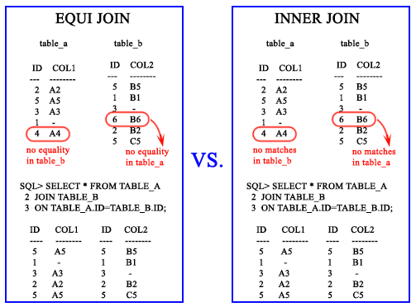

NON EQUI JOIN
The SQL NON EQUI JOIN uses comparison operator instead of the equal sign like >, <, >=, <= along with conditions.
Syntax:
SELECT *
FROM table_name1, table_name2
WHERE table_name1.column [> | < | >= | <= ] table_name2.column;
Pictorial representation:
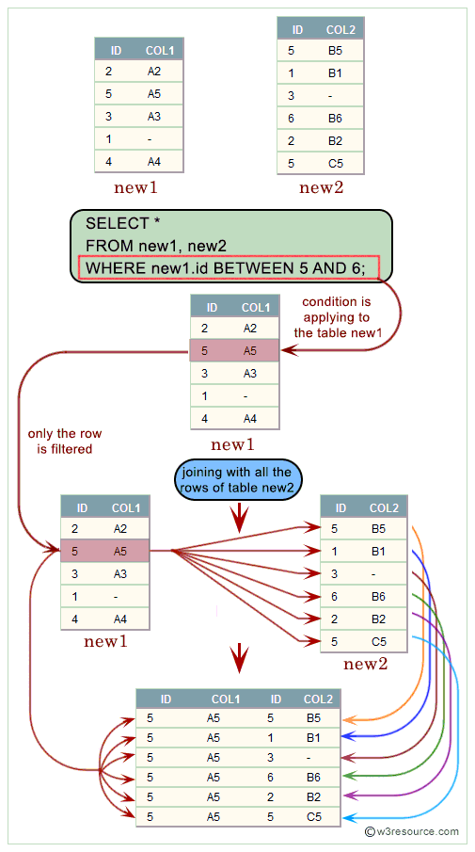
Example:
Here is an example of non equi join in SQL between two tables
Sample table: orders

Sample table: customer

To get order number and order amount columns from orders table aliased as 'a' and customer name and working area columns from customer table aliased as 'b' after joining said two tables with the following condition -
1. order amount of orders table matches any of the opening amounts of customer table,
the following SQL statement can be used:
SQL Code:
SELECT a.ord_num,a.ord_amount,b.cust_name,b.working_area
FROM orders a,customer b
WHERE a.ord_amount
BETWEEN b.opening_amt AND b.opening_amt;
Copy
Output:
ORD_NUM ORD_AMOUNT CUST_NAME WORKING_AREA
--------- ---------- ---------------------------------------- -------------
200110 3000 Micheal New York
200101 3000 Micheal New York
200108 4000 Cook London
200119 4000 Cook London
200113 4000 Cook London
200108 4000 Karl London
200119 4000 Karl London
200113 4000 Karl London

////////////////////

What is Inner Join in SQL?
The INNER JOIN selects all rows from both participating tables as long as there is a match between the columns. An SQL INNER JOIN is same as JOIN clause, combining rows from two or more tables.
Syntax:
SELECT *
FROM table1 INNER JOIN table2
ON table1.column_name = table2.column_name;
OR
SELECT *
FROM table1
JOIN table2
ON table1.column_name = table2.column_name;
Pictorial Presentation:
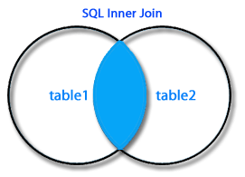
The INNER JOIN in SQL joins two tables according to the matching of a certain criteria using a comparison operator.
Syntax diagram - INNER JOIN
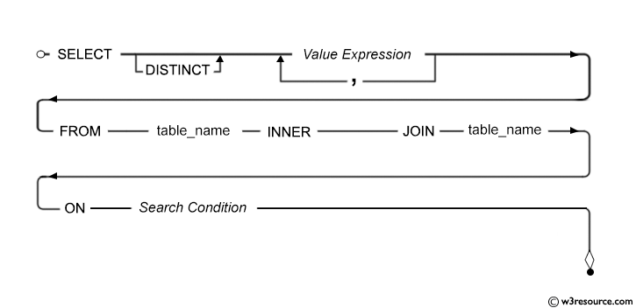
Example: SQL INNER JOIN between two tables
Here is an example of inner join in SQL between two tables.
Sample table: foods

Sample table: company

To join item name, item unit columns from foods table and company name, company city columns from company table, with the following condition -
1. company_id of foods and company table must be same,
the following SQL statement can be used :
SQL Code:
SELECT foods.item_name,foods.item_unit,
company.company_name,company.company_city
FROM foods
INNER JOIN company
ON foods.company_id =company.company_id;
Copy
Output:
ITEM_NAME ITEM_ COMPANY_NAME COMPANY_CITY
------------------------- ----- ------------------------- --------------
Chex Mix Pcs Akas Foods Delhi
Cheez-It Pcs Jack Hill Ltd London
BN Biscuit Pcs Jack Hill Ltd London
Mighty Munch Pcs Foodies. London
Pot Rice Pcs Jack Hill Ltd London
Jaffa Cakes Pcs Order All Boston
Example of SQL INNER JOIN using JOIN keyword
To get item name, item unit columns from foods table and company name, company city columns from company table, after joining these mentioned tables, with the following condition -
1. company id of foods and company id of company table must be same,
the following SQL statement can be used:
SQL Code:
SELECT foods.item_name,foods.item_unit,
company.company_name,company.company_city
FROM foods
JOIN company
ON foods.company_id =company.company_id;
Copy
Output:
ITEM_NAME ITEM_ COMPANY_NAME COMPANY_CITY
------------------------- ----- ------------------------- -------------
Chex Mix Pcs Akas Foods Delhi
Cheez-It Pcs Jack Hill Ltd London
BN Biscuit Pcs Jack Hill Ltd London
Mighty Munch Pcs Foodies. London
Pot Rice Pcs Jack Hill Ltd London
Jaffa Cakes Pcs Order All Boston
Pictorial Presentation:
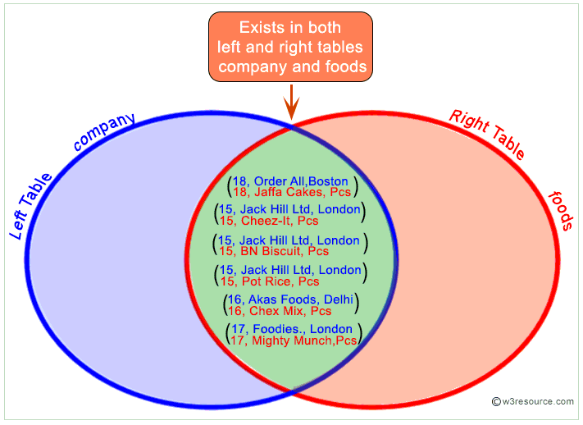

SQL INNER JOIN for all columns
To get all the columns from foods and company table after joining, with the following condition -
1. company id of foods and company id of company table must be same,
the following SQL statement can be used:
SQL Code:
SELECT *
FROM foods
JOIN company
ON foods.company_id =company.company_id;
Copy
Output:
ITEM_ID ITEM_NAME ITEM_ COMPAN COMPAN COMPANY_NAME COMPANY_CITY
-------- ------------------------- ----- ------ ------ ------------------------- -------------
1 Chex Mix Pcs 16 16 Akas Foods Delhi
6 Cheez-It Pcs 15 15 Jack Hill Ltd London
2 BN Biscuit Pcs 15 15 Jack Hill Ltd London
3 Mighty Munch Pcs 17 17 Foodies. London
4 Pot Rice Pcs 15 15 Jack Hill Ltd London
5 Jaffa Cakes Pcs 18 18 Order All Boston

Difference between JOIN and INNER JOIN
JOIN returns all rows from tables where the key record of one table is equal to the key records of another table.
The INNER JOIN selects all rows from both participating tables as long as there is a match between the columns. An SQL INNER JOIN is same as JOIN clause, combining rows from two or more tables.
An inner join of A and B gives the result of A intersect B, i.e. the inner part of a Venn diagram intersection.
Inner joins use a comparison operator to match rows from two tables based on the values in common columns from each table. For example, retrieving all rows where the student identification number is the same for both the students and courses tables.
Using JOIN Clause
SELECT * FROM
Table1 JOIN Table2
ON Table1.column_name=Table2.column_name;
Copy
Using INNER JOIN Clause
SELECT *
FROM Table1 INNER JOIN Table2
ON Table1.column_name= Table2.column_name;
Copy

Difference between INNER JOIN and OUTER JOIN
An INNER JOIN is such type of join that returns all rows from both the participating tables where the key record of one table is equal to the key records of another table. This type of join required a comparison operator to match rows from the participating tables based on a common field or column of both the tables.
Where as the OUTER JOIN returns all rows from the participating tables which satisfy the condition and also those rows which do not match the condition will appear in this operation. This result set can appear in three types of format -
The first one is LEFT OUTER JOIN, in this join includes all the rows from a left table of JOIN clause and the unmatched rows from a right table with NULL values for selected columns.
The second one is RIGHT OUTER JOIN, in this join includes all rows from the right of JOIN cause and the unmatched rows from the left table with NULL values for selected columns.
The last one in FULL OUTER JOIN, in this join, includes the matching rows from the left and right tables of JOIN clause and the unmatched rows from left and right table with NULL values for selected columns.
Example:
Here is two table tableX and tableY and they have no duplicate rows in each. In tableX the values ( A,B) are unique and in tableY the values (E,F) are unique, but the values (C and D) are common in both the tables.
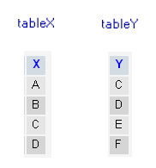
Here is INNER JOIN
SELECT *
FROM tableX
INNER JOIN tableY on tableX.X = tableY.Y;
Copy
or
SELECT tableX.*,tableY.*
FROM tableX,tableY
WHERE tableX.X = tableY.Y;
Copy
Output:
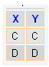
Here only the matching of both tableX and tableY have appeared in the result set.
Here is LEFT OUTER JOIN
SELECT tableX.*,tableY.*
FROM tableX,tableY
WHERE tableX.X = tableY.Y(+)
Copy
or
SELECT *
FROM tableX
LEFT OUTER JOIN tableY ON tableX.X= tableY.Y
Copy
Output:
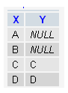
Here all the rows from tableX that is left side of JOIN clause and all the rows with NULL values for unmatched columns from tableY that is the right side of JOIN clause have appeared.
Here is RIGHT OUTER JOIN
SELECT * FROM tableX
RIGHT OUTER JOIN tableY ON tableX.X= tableY.Y
Copy
Output:
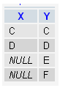
Here all the rows from tableY that is the right side of JOIN clause and all the rows with NULL values for unmatched columns from tableX that is left side of JOIN clause have appeared.
Here is FULL OUTER JOIN
SELECT *
FROM tableX
FULL OUTER JOIN tableY ON tableX.X= tableY.Y
Copy
Output:
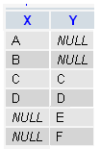
Here all the matching rows from tableX and tableY and all the unmatched rows with NULL values for both the tables have appeared.

INNER JOIN ON vs WHERE clause
The WHERE clause, what is done is that all records that match the WHERE condition are included in the result set but an INNER JOIN is that, data not matching the JOIN condition is excluded from the result set.
Linking between two or more tables should be done using an INNER JOIN ON clause but filtering on individual data elements should be done with WHERE clause.
INNER JOIN is ANSI syntax whereas the WHERE syntax is more relational model oriented.
The INNER JOIN is generally considered more readable and it is a cartesian product of the tables, especially when you join lots of tables but the result of two tables JOIN'ed can be filtered on matching columns using the WHERE clause.
////////////////////////

What is Natural Join in SQL?
We have already learned that an EQUI JOIN performs a JOIN against equality or matching column(s) values of the associated tables and an equal sign (=) is used as comparison operator in the where clause to refer equality.
The SQL NATURAL JOIN is a type of EQUI JOIN and is structured in such a way that, columns with the same name of associated tables will appear once only.
Natural Join: Guidelines
- The associated tables have one or more pairs of identically named columns.
- The columns must be the same data type.
- Don’t use ON clause in a natural join.
Syntax:
SELECT *
FROM table1
NATURAL JOIN table2;
Example:
Here is an example of SQL natural join between tow tables:
Sample table: foods

Sample table: company

To get all the unique columns from foods and company tables, the following SQL statement can be used:
SQL Code:
SELECT *
FROM foods
NATURAL JOIN company;
Copy
Output:
COMPANY_ID ITEM_ID ITEM_NAME ITEM_UNIT COMPANY_NAME COMPANY_CITY
---------- ---------- ------------------------- ---------- ------------------------- --------------
16 1 Chex Mix Pcs Akas Foods Delhi
15 6 Cheez-It Pcs Jack Hill Ltd London
15 2 BN Biscuit Pcs Jack Hill Ltd London
17 3 Mighty Munch Pcs Foodies. London
15 4 Pot Rice Pcs Jack Hill Ltd London
18 5 Jaffa Cakes Pcs Order All Boston
Pictorial presentation of the above Natural Join:
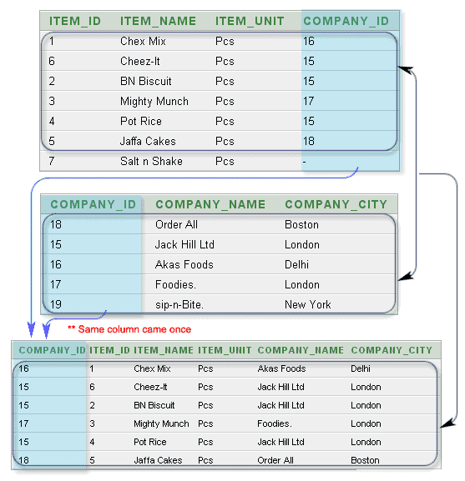

Difference between natural join and inner join
There is one significant difference between INNER JOIN and NATURAL JOIN is the number of columns returned. See the following example on company table and foods table :
SQL Code:
SELECT *
FROM company;
Copy
Output:
COMPANY_ID COMPANY_NAME COMPANY_CITY
---------- ------------------------- ---------------
18 Order All Boston
15 Jack Hill Ltd London
16 Akas Foods Delhi
17 Foodies. London
19 sip-n-Bite. New York
SQL Code:
SELECT *
FROM foods;
Copy
Output:
ITEM_ID ITEM_NAME ITEM_UNIT COMPANY_ID
---------- ------------------------- ---------- ----------
1 Chex Mix Pcs 16
6 Cheez-It Pcs 15
2 BN Biscuit Pcs 15
3 Mighty Munch Pcs 17
4 Pot Rice Pcs 15
5 Jaffa Cakes Pcs 18
7 Salt n Shake Pcs
The INNER JOIN of company and foods on company_id will return :
SQL Code:
SELECT *
FROM company
INNER JOIN foods
ON company.company_id = foods.company_id;
Copy
Output:
COMPANY_ID COMPANY_NAME COMPANY_CITY ITEM_ID ITEM_NAME ITEM_UNIT COMPANY_ID
---------- --------------- --------------- ---------- --------------- ---------- ----------
16 Akas Foods Delhi 1 Chex Mix Pcs 16
15 Jack Hill Ltd London 6 Cheez-It Pcs 15
15 Jack Hill Ltd London 2 BN Biscuit Pcs 15
17 Foodies. London 3 Mighty Munch Pcs 17
15 Jack Hill Ltd London 4 Pot Rice Pcs 15
18 Order All Boston 5 Jaffa Cakes Pcs 18
SQL Code:
SELECT *
FROM company
NATURAL JOIN foods;
Copy
Output:
COMPANY_ID COMPANY_NAME COMPANY_CITY ITEM_ID ITEM_NAME ITEM_UNIT
---------- --------------- --------------- ---------- --------------- ----------
16 Akas Foods Delhi 1 Chex Mix Pcs
15 Jack Hill Ltd London 6 Cheez-It Pcs
15 Jack Hill Ltd London 2 BN Biscuit Pcs
17 Foodies. London 3 Mighty Munch Pcs
15 Jack Hill Ltd London 4 Pot Rice Pcs
18 Order All Boston 5 Jaffa Cakes Pcs
NATURAL JOINS: Relational Databases
- Oracle NATURAL JOIN
////////////////////////////////

What is Cross Join in SQL?
The SQL CROSS JOIN produces a result set which is the number of rows in the first table multiplied by the number of rows in the second table if no WHERE clause is used along with CROSS JOIN.This kind of result is called as Cartesian Product.
If WHERE clause is used with CROSS JOIN, it functions like an INNER JOIN.
An alternative way of achieving the same result is to use column names separated by commas after SELECT and mentioning the table names involved, after a FROM clause.
Syntax:
SELECT *
FROM table1
CROSS JOIN table2;
Pictorial Presentation of Cross Join syntax
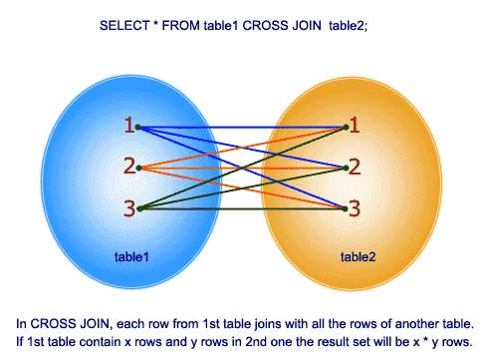
Example:
Here is an example of cross join in SQL between two tables.
Sample table: foods

Sample table: company

To get item name and item unit columns from foods table and company name, company city columns from company table, after a CROSS JOINING with these mentioned tables, the following SQL statement can be used:
SQL Code:
SELECT foods.item_name,foods.item_unit,
company.company_name,company.company_city
FROM foods
CROSS JOIN company;
Copy
or
SQL Code:
SELECT foods.item_name,foods.item_unit,
company.company_name,company.company_city
FROM foods,company;
Copy
How cross joining happend into two tables
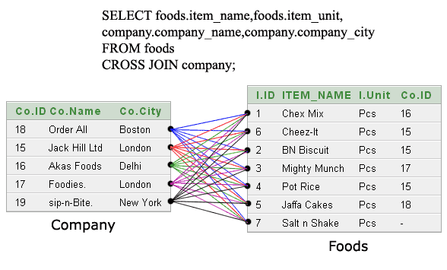
Output:
ITEM_NAME ITEM_UNIT COMPANY_NAME COMPANY_CITY
--------------- ---------- --------------- ---------------
Chex Mix Pcs Order All Boston
Cheez-It Pcs Order All Boston
BN Biscuit Pcs Order All Boston
Mighty Munch Pcs Order All Boston
Pot Rice Pcs Order All Boston
Jaffa Cakes Pcs Order All Boston
Salt n Shake Pcs Order All Boston
Chex Mix Pcs Jack Hill Ltd London
Cheez-It Pcs Jack Hill Ltd London
BN Biscuit Pcs Jack Hill Ltd London
Mighty Munch Pcs Jack Hill Ltd London
Pot Rice Pcs Jack Hill Ltd London
Jaffa Cakes Pcs Jack Hill Ltd London
Salt n Shake Pcs Jack Hill Ltd London
Chex Mix Pcs Akas Foods Delhi
Cheez-It Pcs Akas Foods Delhi
BN Biscuit Pcs Akas Foods Delhi
Mighty Munch Pcs Akas Foods Delhi
Pot Rice Pcs Akas Foods Delhi
Jaffa Cakes Pcs Akas Foods Delhi
Salt n Shake Pcs Akas Foods Delhi
Chex Mix Pcs Foodies. London
.........
.........
More presentaion of the said output:

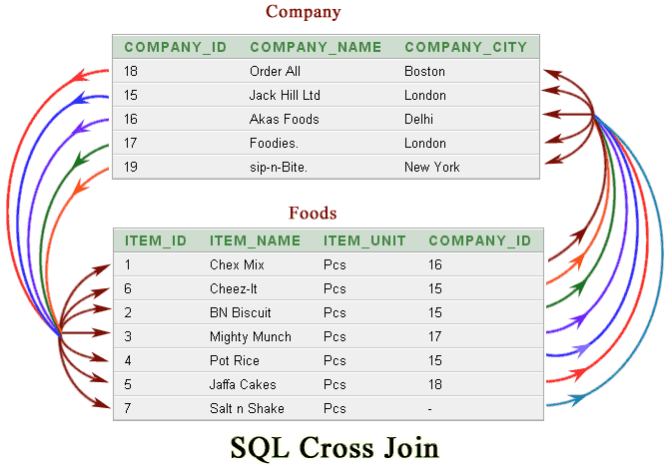

//////////////

OUTER JOIN
The SQL OUTER JOIN returns all rows from both the participating tables which satisfy the join condition along with rows which do not satisfy the join condition. The SQL OUTER JOIN operator (+) is used only on one side of the join condition only.
The subtypes of SQL OUTER JOIN
- LEFT OUTER JOIN or LEFT JOIN
- RIGHT OUTER JOIN or RIGHT JOIN
- FULL OUTER JOIN
Syntax:
Select *
FROM table1, table2
WHERE conditions [+];
Example:
Here is an example of outer join in SQL between two tables.
Sample table: foods

Sample table: company

To get company name and company id columns from company table and company id, item name, item unit columns from foods table, after an OUTER JOINING with these mentioned tables, the following SQL statement can be used:
SQL Code:
SELECT company.company_name,company.company_id,
foods.company_id,foods.item_name,foods.item_unit
FROM company, foods
WHERE company.company_id = foods.company_id(+);
Copy
Explanation:
This SQL statement would return all rows from the company table and only those rows from the foods table where the joined fields are equal.
The (+) after the foods.company_id field indicates that, if a company_id value in the company table does not exist in the foods table, all fields in the foods table will be displayed as NULL in the result set.
Pictorial Presentation of SQL outer join
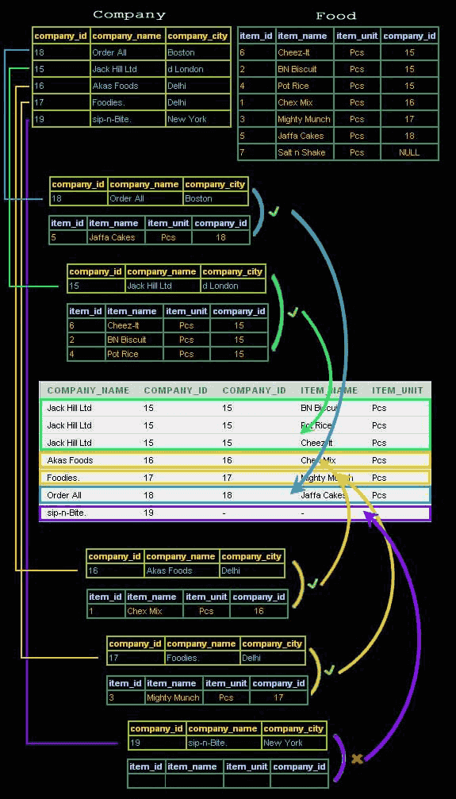
Output:
COMPANY_NAME COMPANY_ID COMPANY_ID ITEM_NAME ITEM_UNIT
--------------- ---------- ---------- --------------- ----------
Akas Foods 16 16 Chex Mix Pcs
Jack Hill Ltd 15 15 Cheez-It Pcs
Jack Hill Ltd 15 15 BN Biscuit Pcs
Foodies. 17 17 Mighty Munch Pcs
Jack Hill Ltd 15 15 Pot Rice Pcs
Order All 18 18 Jaffa Cakes Pcs
sip-n-Bite. 19

////////////////////

LEFT JOIN
The SQL LEFT JOIN (specified with the keywords LEFT JOIN and ON) joins two tables and fetches all matching rows of two tables for which the SQL-expression is true, plus rows from the frist table that do not match any row in the second table.
Left Join: Syntax
SELECT *
FROM table1
LEFT [ OUTER ] JOIN table2
ON table1.column_name=table2.column_name;
Pictorial representation:

SQL LEFT join fetches a complete set of records from table1, with the matching records (depending on the availability) in table2. The result is NULL in the right side when no matching will take place.
Syntax diagram - LEFT JOIN
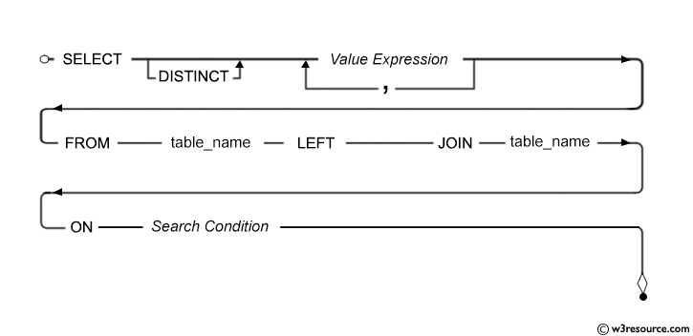

Example of SQL Left Join
To get company name and company id columns from company table and company id, item name, item unit columns from foods table, after an OUTER JOINING with these mentioned tables, the following SQL statement can be used :
Sample table: foods

Sample table: company

SQL Code:
SELECT company.company_id,company.company_name,
company.company_city,foods.company_id,foods.item_name
FROM company
LEFT JOIN foods
ON company.company_id = foods.company_id;
Copy
Explanation:
This SQL statement would return all rows from the company table and only those rows from the foods table where the joined fields are equal and if the ON clause matches no records in the 'foods' table, the join will still return rows, but the NULL in each column of the right table.
Output:
COMPANY_ID COMPANY_NAME COMPANY_CITY COMPANY_ID ITEM_NAME
---------- ------------------------- ------------------------- ---------- --------------
16 Akas Foods Delhi 16 Chex Mix
15 Jack Hill Ltd London 15 Cheez-It
15 Jack Hill Ltd London 15 BN Biscuit
17 Foodies. London 17 Mighty Munch
15 Jack Hill Ltd London 15 Pot Rice
18 Order All Boston 18 Jaffa Cakes
19 sip-n-Bite. New York
Pictorial Presentation of the above example:
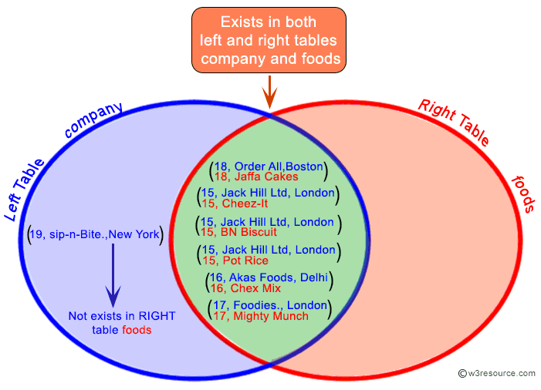

Example of SQL Left Join using multiple columns
To filtered out those bill number, item name and the bill amount for each bill which bill amount exceeds the value 500 and must be available at the food stall, the following SQL statement can be used :
Sample table: foods

Sample table: counter_sale

SQL Code:
SELECT a.bill_no, b.item_name, a.bill_amt
FROM counter_sale a
LEFT JOIN foods b
ON a.item_id=b.item_id
WHERE a.bill_amt>500;
Copy
Explanation:
This SQL statement will first join all rows from the counter_sale table and only those rows from the foods table where the joined fields are equal and if the ON clause matches no records in the foods table, the join will still return rows, but the NULL in each column of right table, therefore eliminates those rows which bill amount is less than or equal to 500.
Output:
BILL_NO ITEM_NAME BILL_AMT
---------- ------------------------- ----------
1002 Chex Mix 2000
1006 Mighty Munch 625
1001 Pot Rice 600
1004 Pot Rice 540
1005 Salt n Shake 600
Pictorial Presentation:
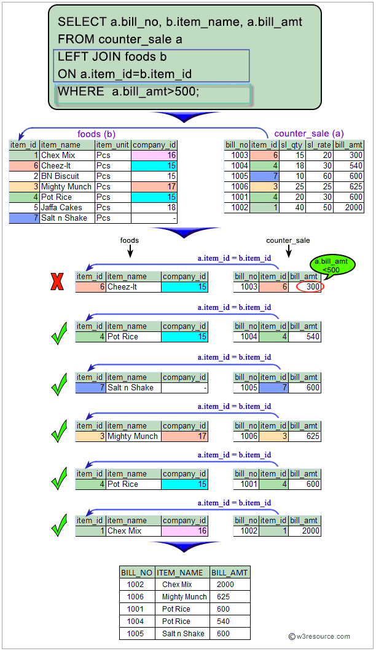
Example of SQL Left Join using multiple tables
To filtered out those bill number, item name, company name and city and the bill amount for each bill, which items are available in foods table, and their manufacturer must have enlisted to supply that item, and no NULL value for manufacturer are not allowed, the following SQL statement can be used:
Sample table: foods

Sample table: company

Sample table: counter_sale

SQL Code:
SELECT a.bill_no, b.item_name,c.company_name,
c.company_city, a.bill_amt
FROM counter_sale a
LEFT JOIN foods b ON a.item_id=b.item_id
LEFT JOIN company c ON b.company_id=c.company_id
WHERE c.company_name IS NOT NULL
ORDER BY a.bill_no;
Copy
Explanation:
This SQL statement will first join all rows from the counter_sale table and only those rows from the foods table where the joined fields are matching and if the ON clause matches no records in the foods table, the join will still return rows, but the NULL in each column of the right table. Therefore this result will join with company table and all rows from result table and matched and unmatched rows from company table will also come, but for the unmatched rows of company table, the column value will be NULL. Therefore the WHERE clause will eliminate those rows which company name column value is NULL and after that, the ORDER BY clause will arrange the rows in ascending order according to the bill number.
Output:
BILL_NO ITEM_NAME COMPANY_NAME COMPANY_CITY BILL_AMT
---------- ------------------------- ------------------------- ------------------------- ----------
1001 Pot Rice Jack Hill Ltd London 600
1002 Chex Mix Akas Foods Delhi 2000
1003 Cheez-It Jack Hill Ltd London 300
1004 Pot Rice Jack Hill Ltd London 540
1006 Mighty Munch Foodies. London 625
Pictorial Presentation:
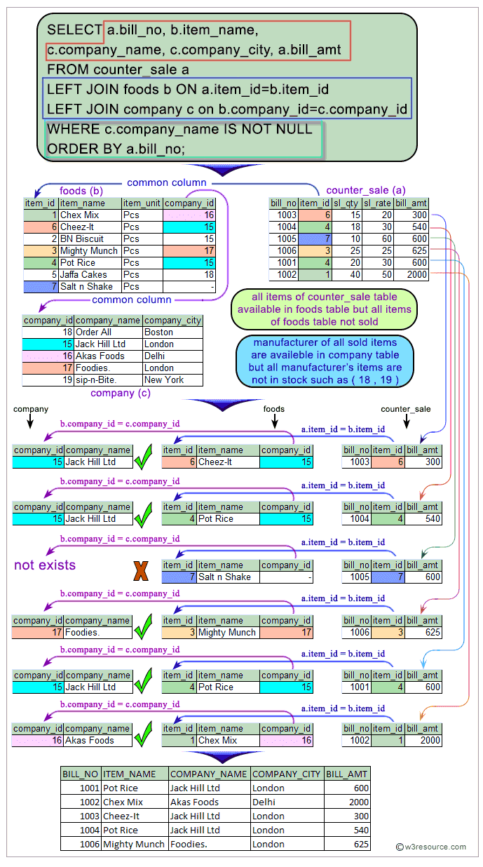

What is the difference between Left Join and Left Outer Join in SQL?
There is actually no difference between a left join and a left outer join – both of them refer to the similar operation in SQL.
Sample table: company
COMPANY_ID COMPANY_NAME COMPANY_CITY
---------- ------------------------- -------------
18 Order All Boston
15 Jack Hill Ltd London
16 Akas Foods Delhi
17 Foodies. London
19 sip-n-Bite. New York
Sample table: foods
ITEM_ID ITEM_NAME ITEM_UNIT COMPANY_ID
-------- ------------------------- ---------- ----------
1 Chex Mix Pcs 16
6 Cheez-It Pcs 15
2 BN Biscuit Pcs 15
3 Mighty Munch Pcs 17
4 Pot Rice Pcs 15
5 Jaffa Cakes Pcs 18
7 Salt n Shake Pcs
The important point to be noted that the very last row in the company table, the company ID does not exist in the foods table. Also, the very last row in the foods table the value of company ID is NULL and does not exist in the company table. These facts will prove to be significant of the left join.
Here the SQL statement without using "outer" with "left join".
SQL Code:
SELECT company.company_id,company.company_name,
foods.item_id, foods.item_name, foods.company_id
FROM company
LEFT JOIN foods
ON company.company_id = foods.company_id;
Copy
Running the SQL with the "outer" keyword, would give us the exact same results as running the SQL without the “outer”. Here the SQL statement with "outer" with "left join".
SQL Code:
SELECT company.company_id,company.company_name,
foods.item_id, foods.item_name, foods.company_id
FROM company
LEFT OUTER JOIN foods
ON company.company_id = foods.company_id;
Copy
A left outer join or left join retains all of the rows of the left table company, regardless of whether there is a row that matches on the right table foods. Here is the output below for both of the above statement.
Output:
COMPANY_ID COMPANY_NAME ITEM_ID ITEM_NAME COMPANY_ID
---------- ------------------------- -------- ------------------------- ----------
16 Akas Foods 1 Chex Mix 16
15 Jack Hill Ltd 6 Cheez-It 15
15 Jack Hill Ltd 2 BN Biscuit 15
17 Foodies. 3 Mighty Munch 17
15 Jack Hill Ltd 4 Pot Rice 15
18 Order All 5 Jaffa Cakes 18
19 sip-n-Bite. NULL NULL NULL
Outputs of the said SQL statement shown here is taken by using Oracle Database 10g Express Edition.
LEFT JOIN: Relational Databases

